***£12.5k+ per session***

***12 appts per session - made up of F2F, tel calls and GP bookable only.***

**Half Day Duty Dr - never do a dreaded full day of duty Dr again!** Duty Dr support with 1st and 2nd GP on and a skilled ANP team providing on the day urgent care cover.

**Low GP visit numbers -** Complex Care team / Community Matrons who cover visits.

Daily coffee break & weekly MDT meetings.

* **Our Team:**
* 4 GP Partners, 1 Managing Partner
* 6 Salaried GPs
* 6 ANPs
* 7 Nurses & 5 HCAs
* Complex Care Team: 3 Community Matrons & 1 Paramedic & 1 Admiral Dementia Nurse
* 2 Clinical Pharmacists and 3 Technicians.
* Experienced Dispensing Teams at both sites
* Social Prescribers
* First contact Physio
* Fantastic Reception/Admin/Secretarial Support
* Teaching Practice for VTS/FY2s/Cambridge and UEA medical students

For an informal chat/arrange a visit/any enquiries please do contact us:

Rigs Whittaker (Managing Partner)

[rigby.whittaker@nhs.net](mailto:rigby.whittaker@nhs.net)

Philippa Haywood-Smith (GP Partner)

[p.haywood-smith@nhs.net](mailto:p.haywood-smith@nhs.net)

01502 722326 / 01986 892055

Sole Bay Health Centre, Reydon, Southwold. IP18 6GY

Bungay Medical Practice, Bungay. NR35 1LP

01234 567 890

Sole Bay Health Centre Bungay Medical Practice

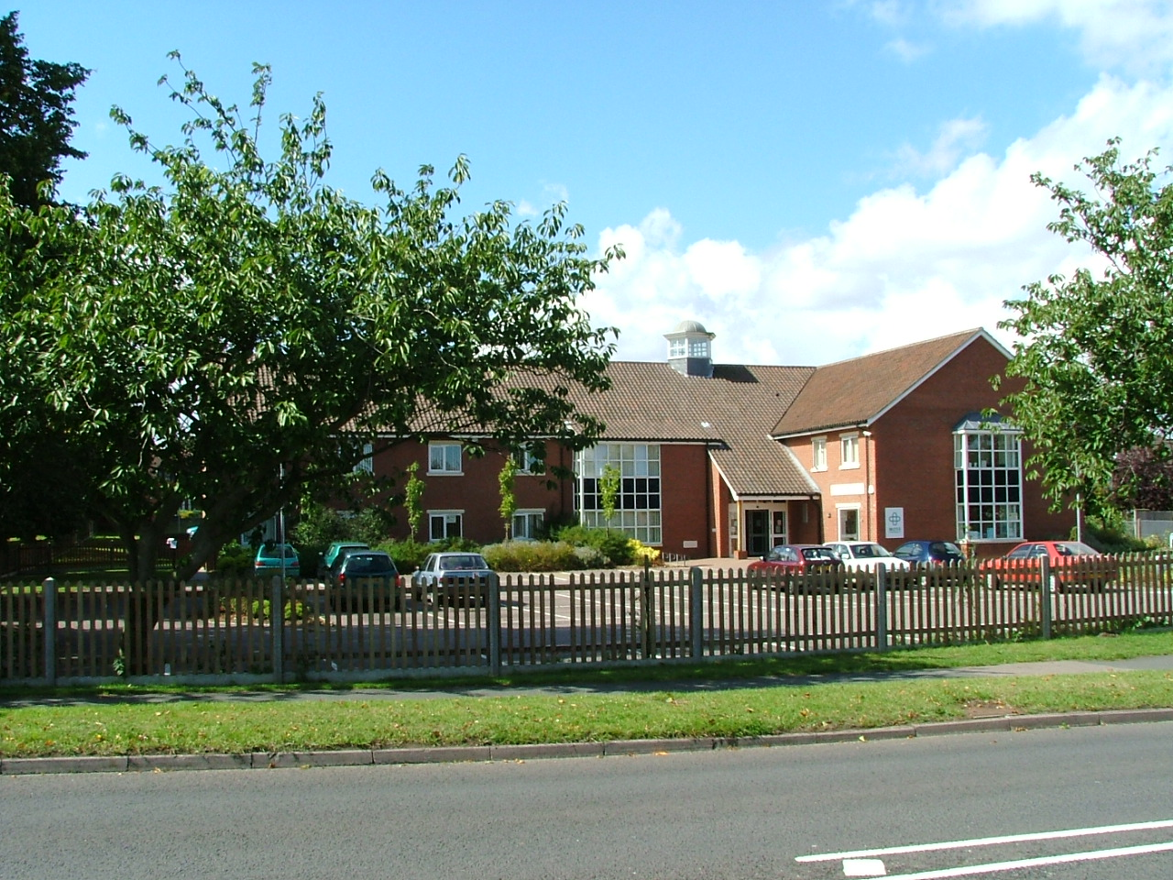

Dr Castle & Partners

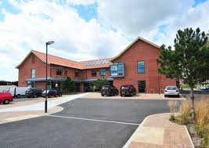

We are looking to recruit a Salaried GP to join our expanding, friendly team at our two practices, one on the stunning Suffolk Coast and one a rural practice on the Norfolk/Suffolk border.

If you are an enthusiastic, forward-thinking individual who is looking to work with a team who is committed to providing the best care to our communities we want to hear from you!