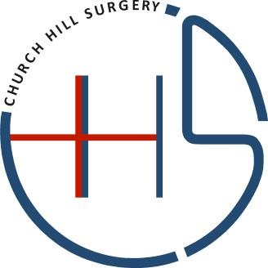

Salaried General Practitioner Church Hill Surgery – Part Time
Church Hill Surgery is a practice of 4500 patients located in Pulham Market in the heart of Norfolk in East Anglia. The surgery is a 30-minute drive to Norwich city and rated Good by the CQC.
We are seeking an ambitious and dedicated GP to join our surgery who will carry on our ethos of delivering high quality patient care alongside our existing excellent clinical team.
Our surgery is made up of 4 GPs, 1 Nurse practitioner, 1 practice Nurse, Phlebotomist, Health care assistant and a dedicated administrative team. We also have a dispensing practice with a very well-run dispensary on site.
The Role
- Salaried GP
- 4-6 sessions a week. Exact working days will be negotiated with the successful candidate
- Above average remuneration package
- To provide clinical care to patients as described in the job plan, this will include consultation sessions, telephone triage, correspondence, results, medication reviews and prescription signing and other clinical administration, safeguarding, medicals, reports, home visits, surgery meetings and on-call.
Responsibilities
- Provide a full range of medical services as defined in the core GMS contract, additional and enhanced services where appropriate.
- Undertake all duties and responsibilities associated with a GP working within primary care.
- Adhere to GMC Good Medical practice.
- Maintain accurate and timely medical records
- Adhere to National and local guidelines (e.g. NICE)
- Engage with local quality Frameworks – e.g. QoF
- Reflect on personal practice through SEA, NHS appraisal, patient complaints

What’s on Offer
- 6 weeks annual leave, plus 1-week study leave pro rata, per annum
- Well established, inclusive clinical governance and meeting structure
- Consistent high delivery of QOF targets
- Supportive team –working ethos, regular catch-up and discussions
- Excellent working environment with a very supportive GP partner
Person Specification
- Current registration with the GMC
- Sound knowledge of the principles and values that support good medical practice
- Good organisational skills
- Excellent interpersonal skills and be committed to working as part of a team
- Excellent communication skills, both written and verbal.
- Clear commitment to delivering quality and patient focused services
- Clinical skills required to manage acute presentations and chronic disease within primary care
- Participation in scheme of extended opening times.
- Commitment to High Standards.

Informal visits and enquiries are welcomed.
For further enquiries please contact the Practice Manager Ifey Enaohwo on 01379676227 or Ifeyinwa.enaohwo@nhs.net

