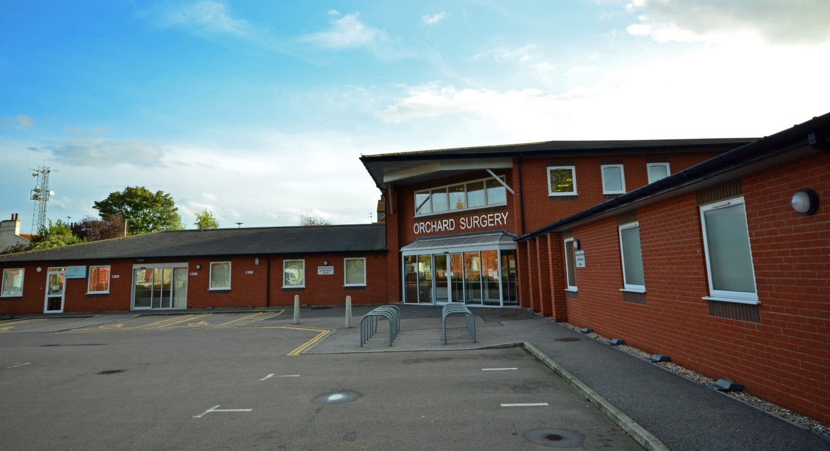

ORCHARD SURGERY
DEREHAM

PRACTICE INFORMATION PACK

We have a list size of approximately 11,000 patients. We cover an area including the town of Dereham and the villages of Beetley, Swanton Morley, Yaxham, Whinburgh, Scarning, Wendling and Gressenhall. The majority of our patients live within a 3 mile radius of the Practice.

We currently have seven GP Partners working a variety of hours.
Dr Senthil Kumar joined the practice in 2006 Dr Janet August in 2009, Dr Andrew Cheesbrough, Dr Sabeena Foster and Dr Vanaja Santosh in 2014, Dr Mary Dun in 2015 and Dr Melanie Hill in 2019.

We moved to our spacious, purpose-built premises in May 2006. We had an active involvement in its design and are rightly proud of the facilities it offers. The building was funded by a private developer and is leased to us, with the rent being reimbursed by NHS England.

We are a paperlite practice operating the SystmOne clinical system. All hospital letters and results are entered direct onto the patient’s computer record and coded by our experienced clinical coding team.

The Partners try very hard to share the workload evenly. We operate by discussion and consensus and believe that our open approach is a great strength.

We have a team of experienced Nurse Practitioners funded by South Norfolk Clinical Commissioning Group who complete the majority of our acute home visits.

A typical working day would comprise:-

- Morning surgery 8.30am – 11.30am with ten minute appointments and five minute phone slots – this is followed by a maximum of two 5 minute slots for “urgent extras”
- Thirty Minute Group coffee break at 10.30am to discuss cases and allocate home visits
- Evening Surgery runs for 2 ½ hours between 2.30pm and 4.50pm with a 30 minute admin slot built in

In addition, we are part of Mid-Norfolk Primary Care Network and offer a variety of Extended Access and Improved Access appointments.

At present, each Partner will have one day a week when they are Duty Doctor (pro rata for part-time partners) which is split into two half days. This means they carry the practice mobile phone and are on call during the day 8.00-1.30 or 1.15 – 6.30pm for any urgent visits or calls for advice.

We look after three residential homes and these are shared equally between the Partners. As previously mentioned the majority of visits are completed by our Visiting Nurse Team.

We hold regular practice meetings as follows:-

- On alternate weeks the Partners, Practice Manager and Business Manager meet to discuss business performance.
- On a monthly basis the clinical team meet for a Significant Event meeting, a Multi-disciplinary team meeting, and a Clinical education meeting.

The practice is actively involved with South Norfolk Clinical Commissioning Group and Mid-Norfolk Primary Care Network. Dr Melanie Hill and Claire Warman Practice Manager meet with them on a Monthly basis.

Orchard Surgery is a teaching and training practice and currently host third year medical students and an ST3 registrar. We are actively involved in Research and are one of the top performing practices in Norfolk. We have been rated as “Good” by CQC and are high QOF achievers

STAFFING STRUCTURE

Claire Warman - Practice Manager (full-time)

Richard Hall - Business Manager (part-time)

Dawn Boyce - Clinical Systems and Data Manager

NURSING TEAM
- Andrew Vokes – Nurse Practitioner
- Maxine Williamson – Nurse Practitioner
- Fiona Lambert – Lead Practice Nurse
- Amie Thrower – Practice Nurse
- Lucy Hyland – Practice Nurse
- Debbie Laws – Lead Healthcare Assistant
- Tracy Parker – Healthcare Assistant
- Nicola Taylor-Woodhouse – Healthcare Assistant

MEDICINE MANAGEMENT TEAM
- Cat Eke – Medicine Management Advisor
- Ellie Rickinson – Medicine Management Administrator

ADMINISTRATION / RECEPTION TEAM
We employ a team of 17 members of staff to provide administrative and reception support to the GPs.

For further information please contact our Practice Manager, Claire Warman Direct dial: 01362 656945 or claire.warman@nhs.net

If you wish to apply, please send your CV with a supporting statement to reach Claire by Friday 7th February 2020.

www.orchardsurgerydereham.co.uk

